Monthly Payment System Indicators – August 2022

Digital Payments – Volume and Value
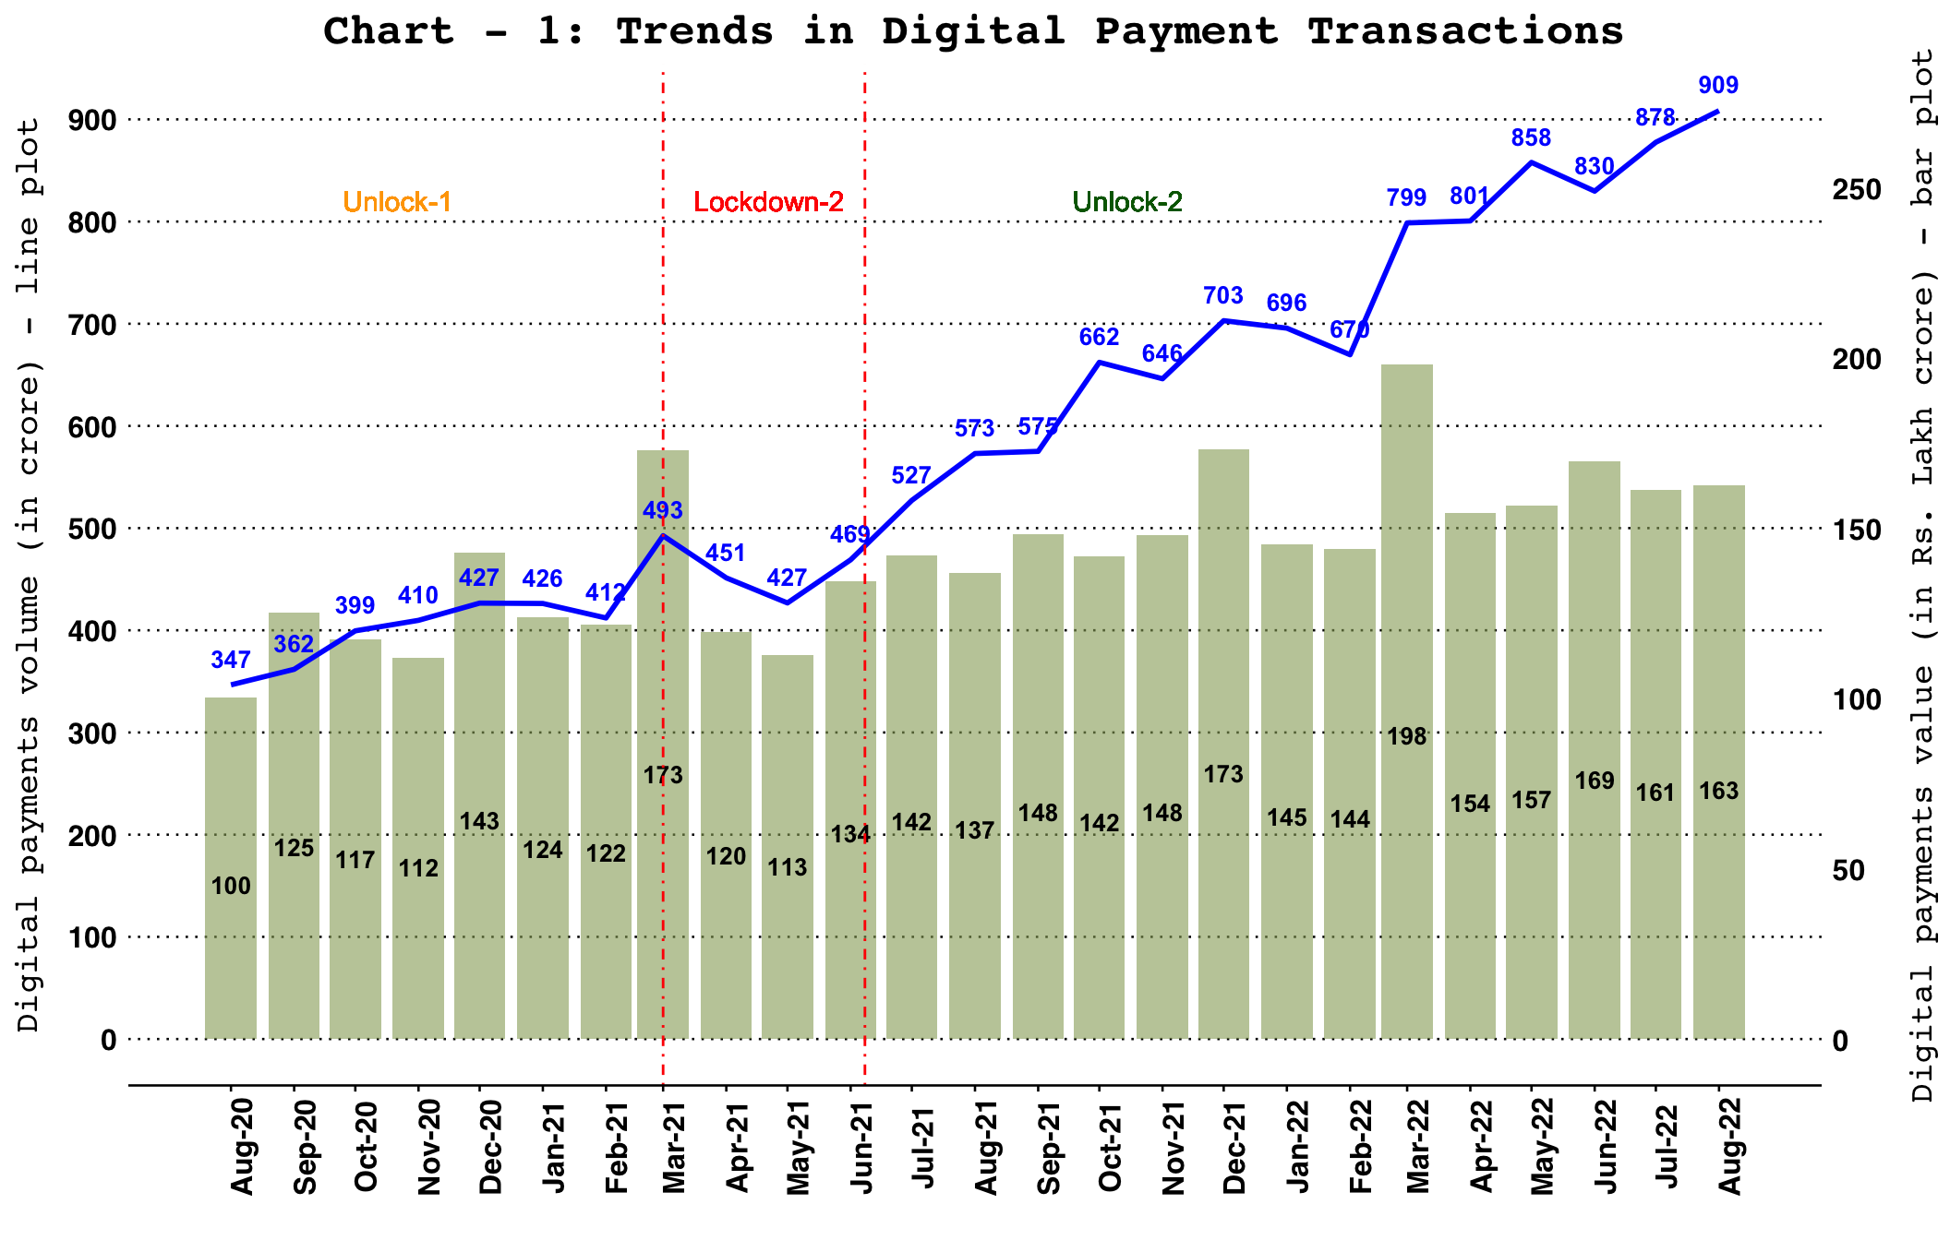
Note: Digital payments include RTGS (customer and inter-bank transactions), retail electronic clearing – NEFT, IMPS, NACH (credit, debit and APBS), card payment transactions (excl. cash withdrawal), PPI payment transactions (excl. cash withdrawal), UPI (including BHIM & USSD), BHIM Aadhaar Pay, AePS fund transfer and NETC (linked to bank accounts).

Retail Payments – Volume and Value
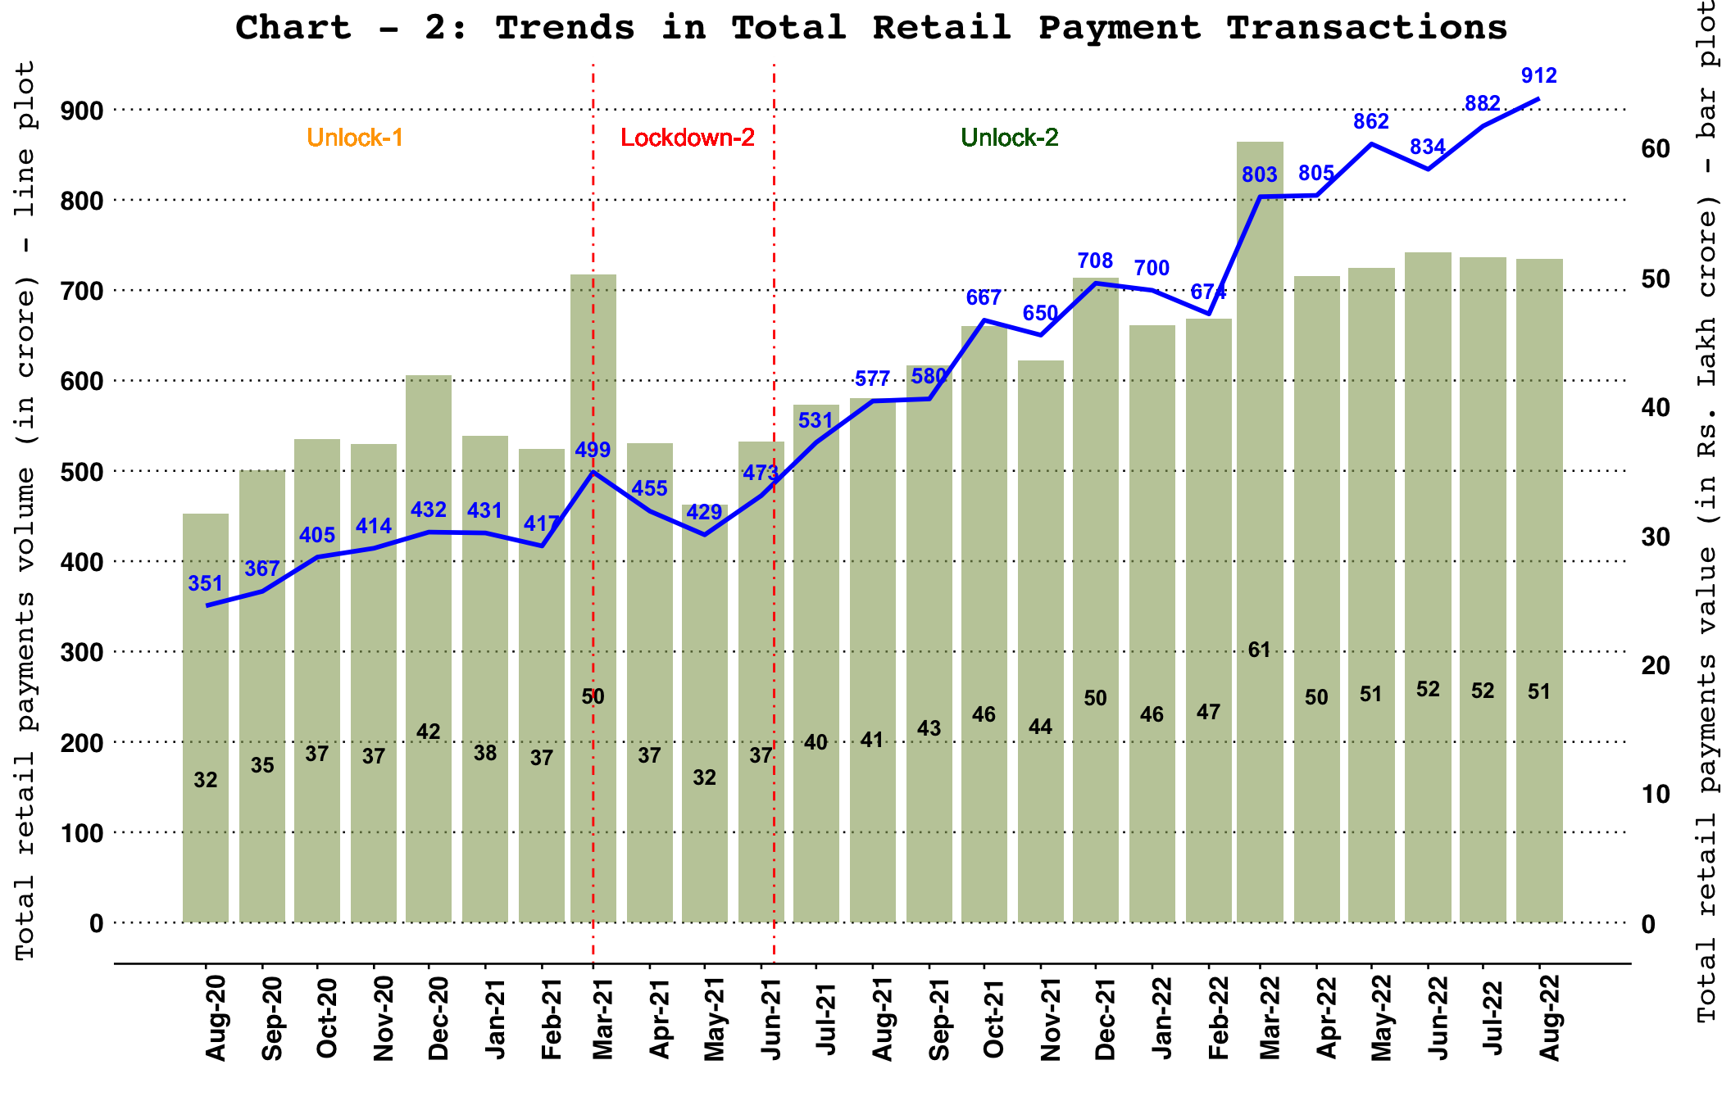
Note: Retail payments include NEFT, IMPS, NACH (credit, debit and APBS), card payment transactions (excl. cash withdrawal), PPI payment transactions (excl. cash withdrawal), UPI (including BHIM & USSD), BHIM Aadhaar Pay, AePS fund transfer and NETC (linked to bank accounts) and paper clearing.

Cards and Prepaid Payment Instruments (PPIs) – Volume and Value
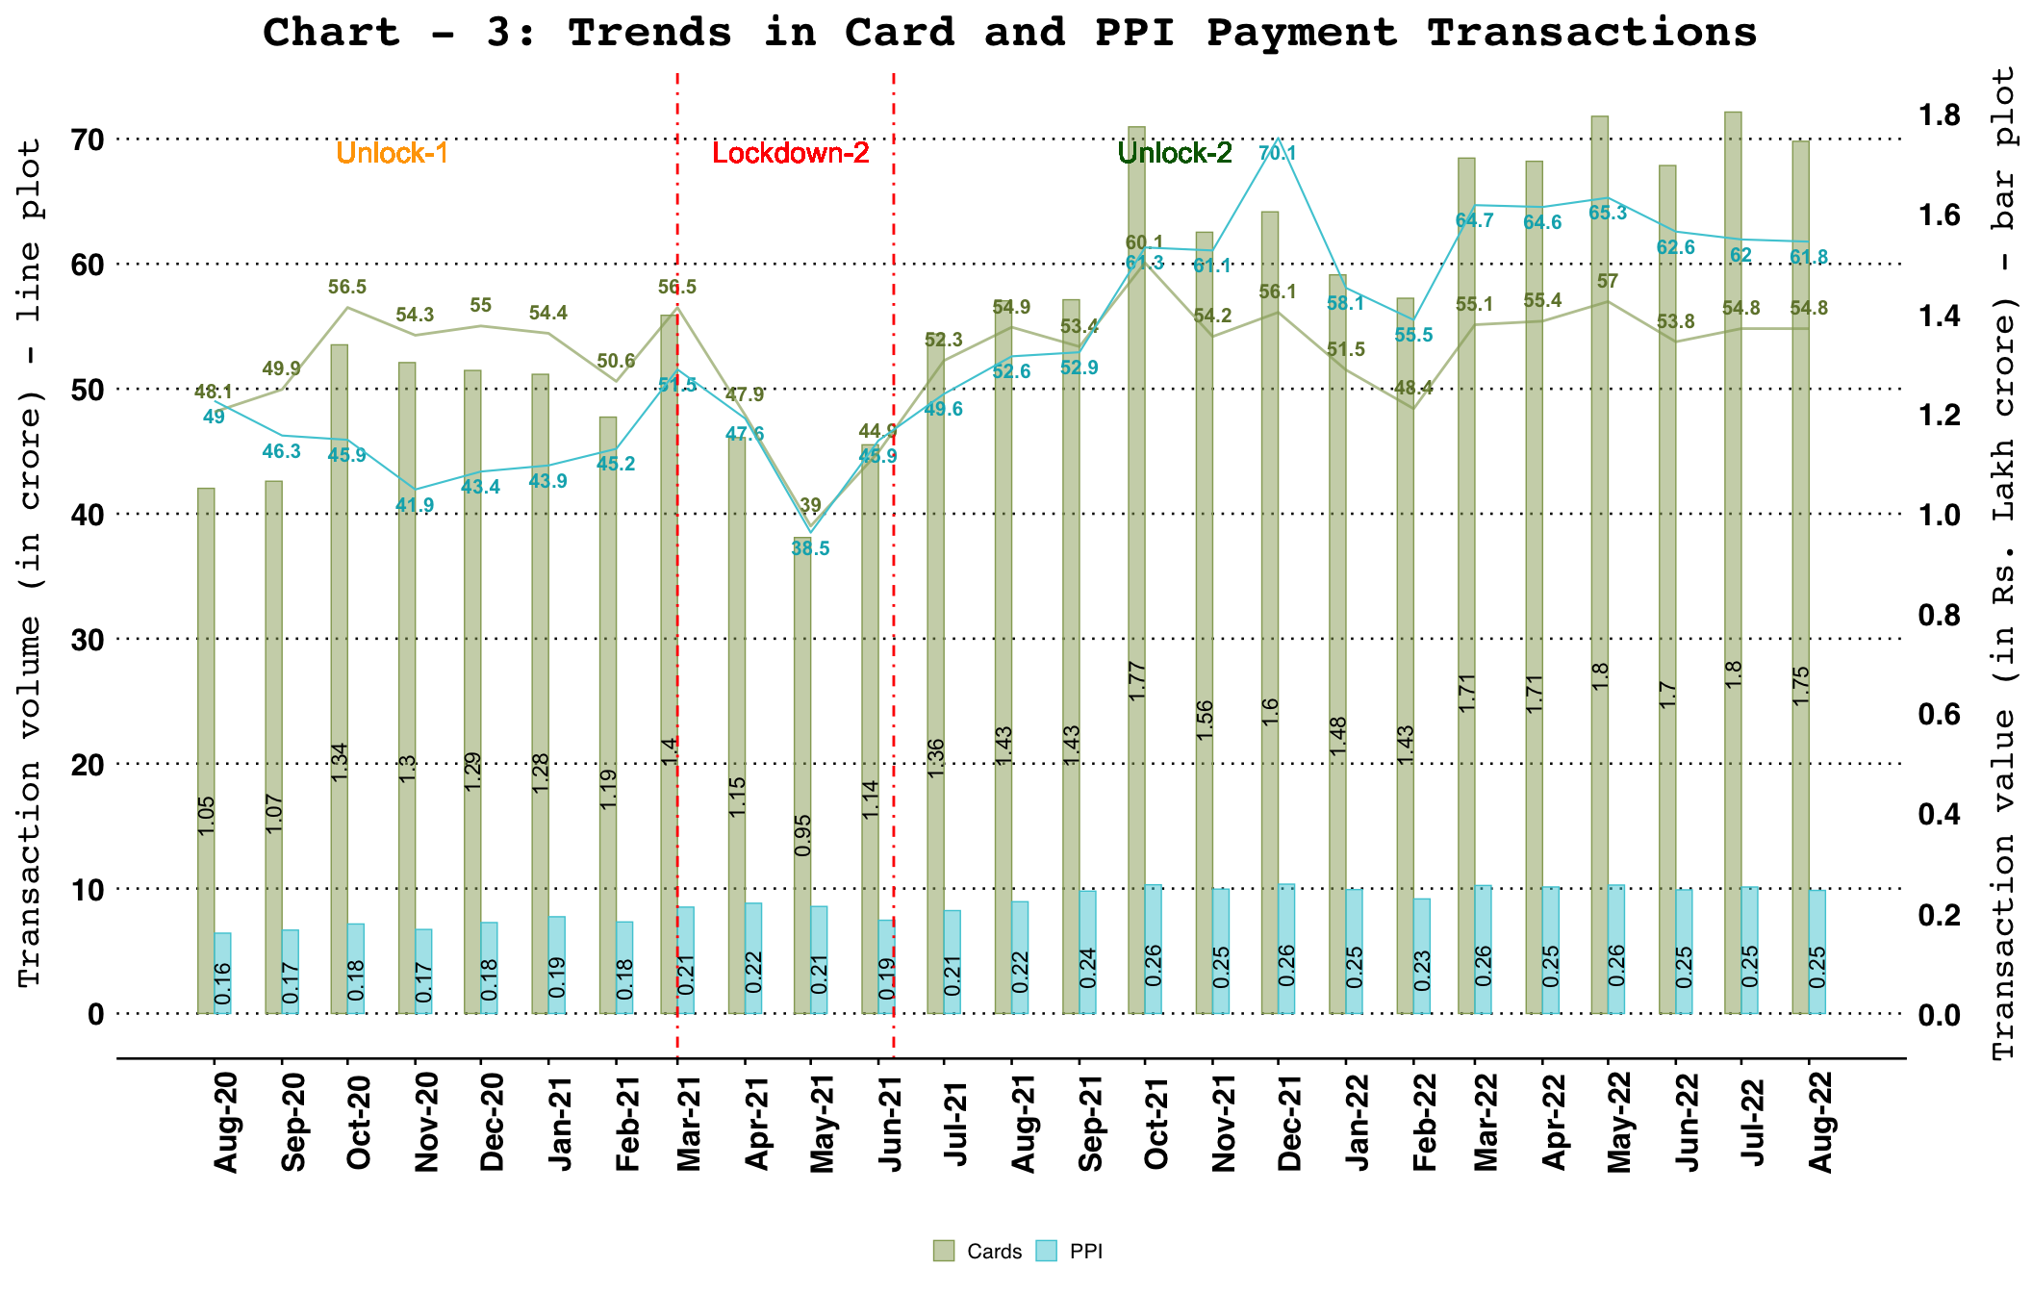
Note: Cards include debit and credit card payment transactions (excl. cash withdrawal) and PPIs include wallet and PPI card payment transactions (excl. cash withdrawal).

Comparison of NPCI, RBI and Other Payment Systems
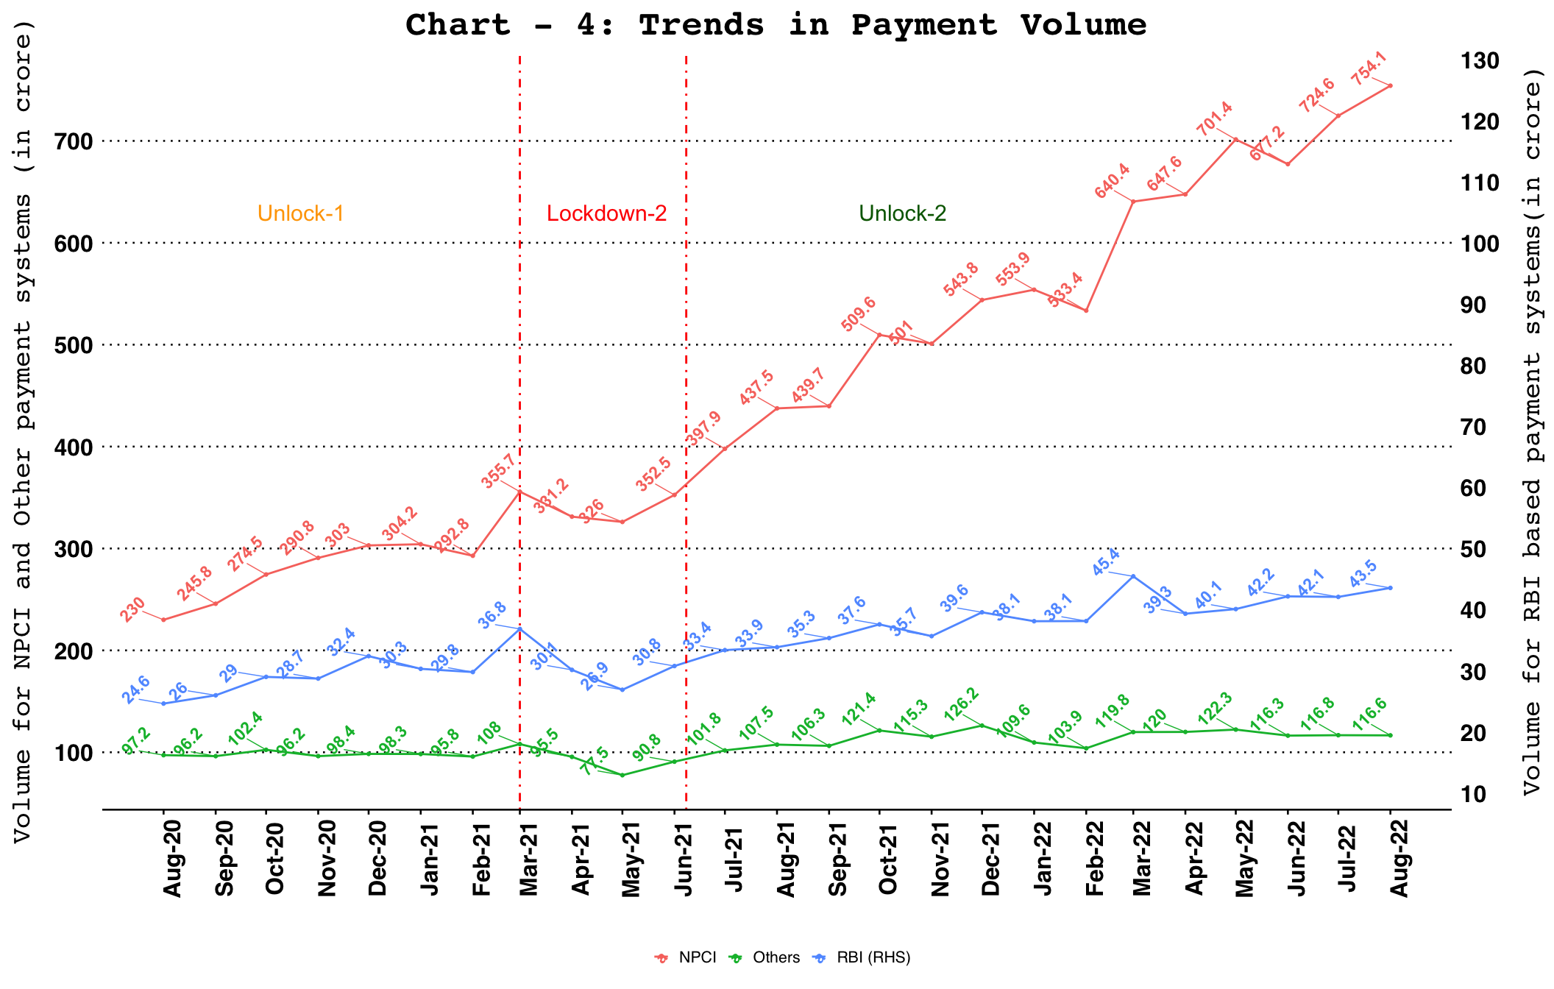
Note:
RBI payment systems include RTGS (customer and inter-bank transactions) and NEFT.
NPCI payment systems include IMPS, NACH, UPI (including BHIM & USSD), BHIM Aadhaar Pay, AePS fund transfer and NETC (linked to bank account).
Other payment systems include debit and credit card payment transactions (excl. cash withdrawal) and wallet and PPI card payment transactions (excl. cash withdrawal).

Payment Systems – Share of Volume and Value

Digital Payments – Volume Share of Payment Systems
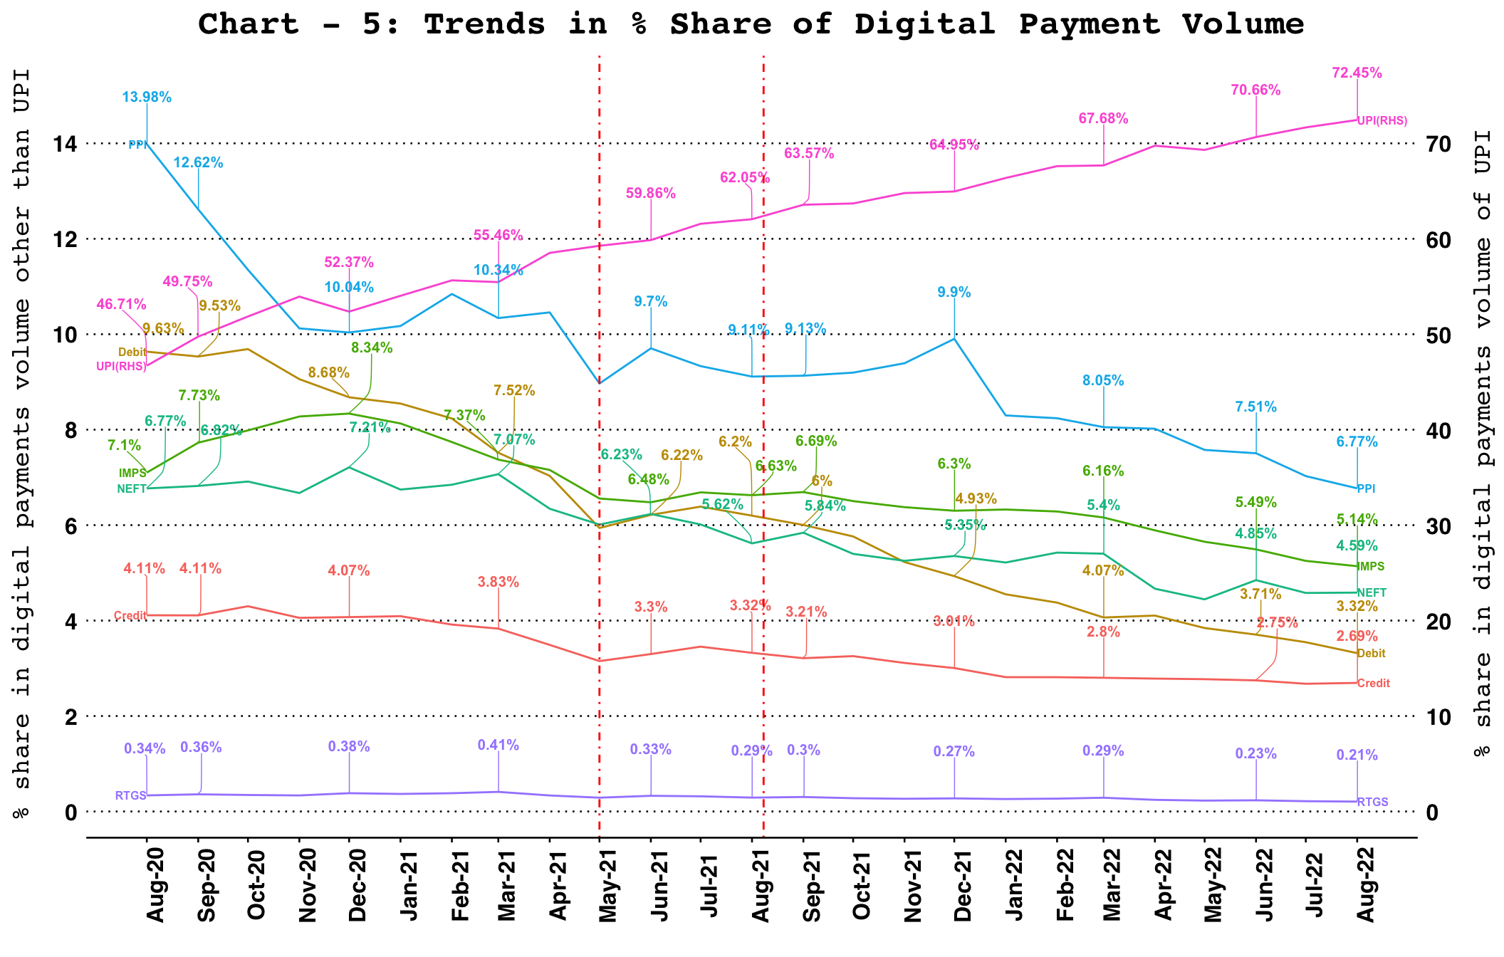

Digital Payments – Value Share of Payment Systems
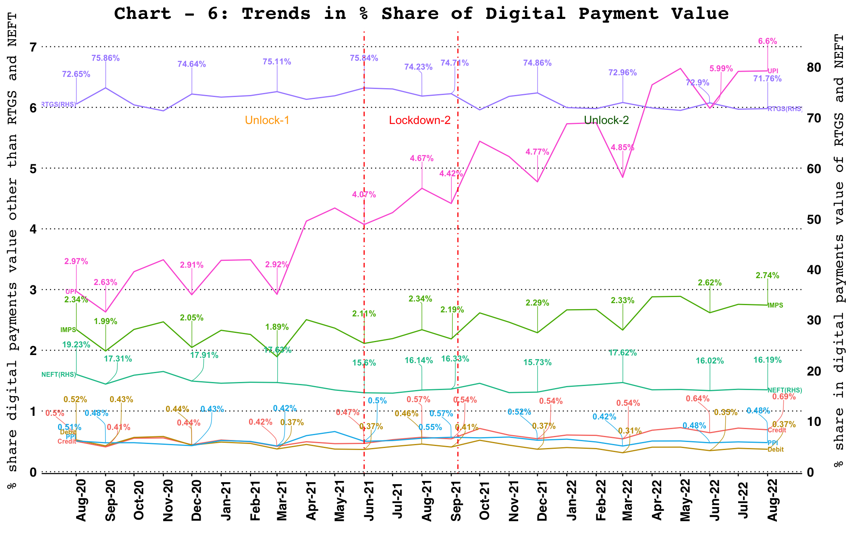

Card Acceptance Infrastructure – ATMs, PoS Terminals and Bharat QR codes
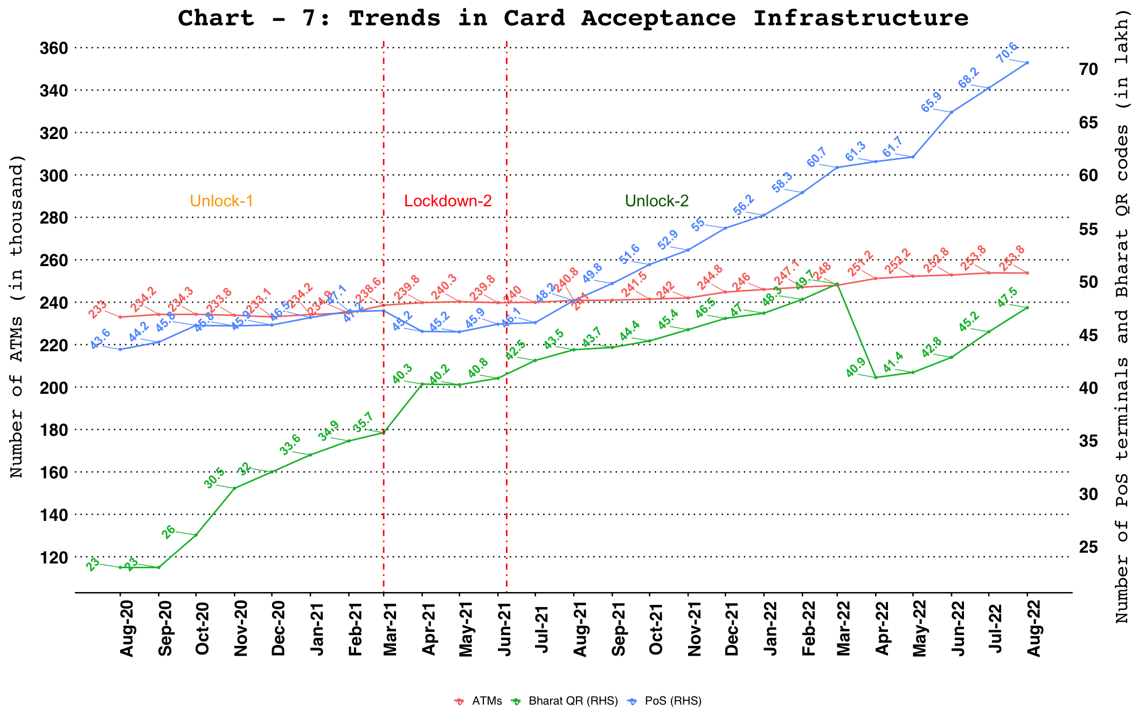

UPI QR codes
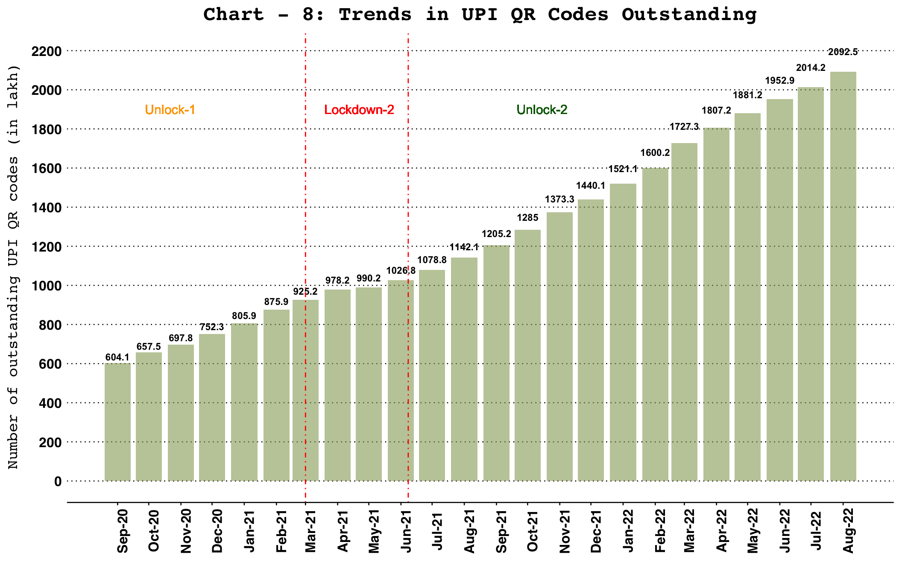

Ticket Size of Retail Payment Systems
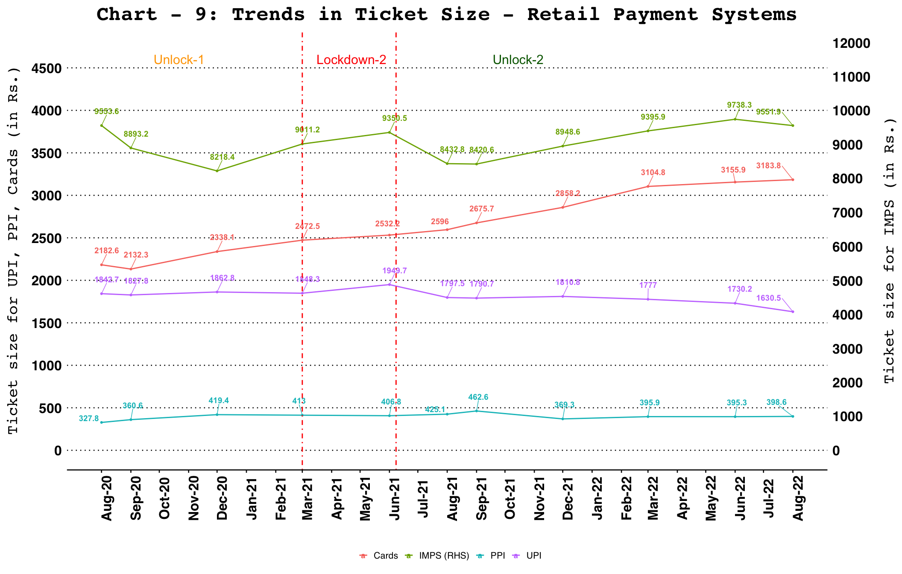
Note:
Ticket size (Average Value Per Transaction) is calculated by dividing the transaction value of a payment system for a given period by its transaction volume during the same period.
Cards include debit and credit card payment transactions (excl. cash withdrawal).

Ticket Size of RTGS and NEFT Systems
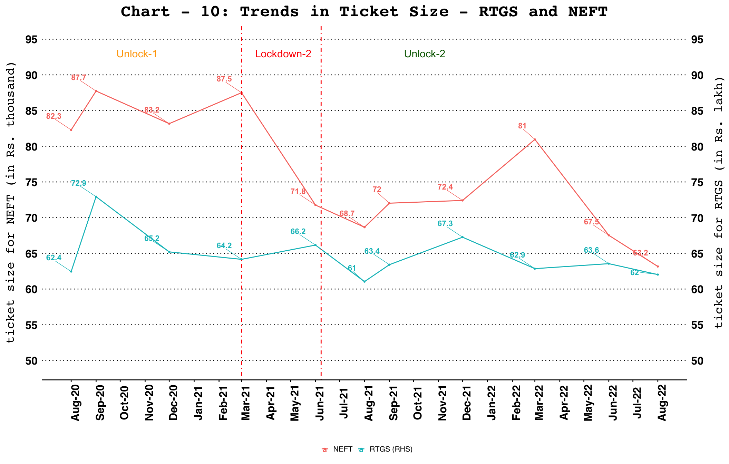
Note:
Ticket size (Average Value Per Transaction) is calculated by dividing the transaction value of a payment system for a given period by its transaction volume during the same period

