Applicability of Disclaimer:
- Download (.NET) Framework in Banking Glossary. “Download Banking Glossary” webpage.
- Download (.NET) Framework in Banking Glossary. “Download Banking Glossary” webpage.
- Download (.NET) Framework in Banking Glossary. “Download Banking Glossary” webpage.

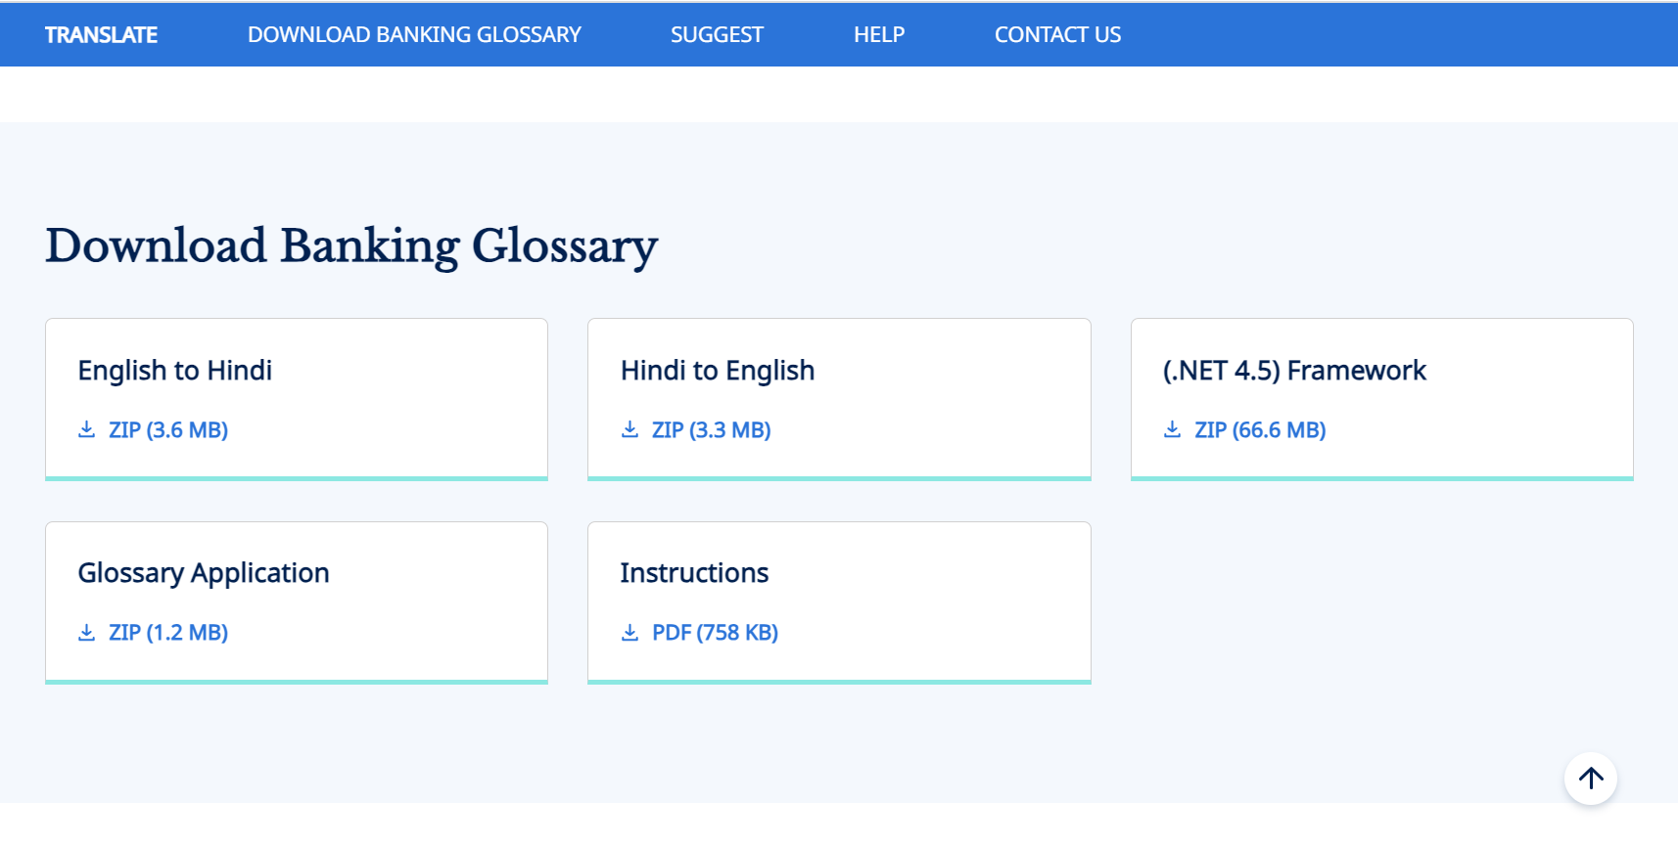
Disclaimer: The software on the website has been scanned and uploaded. User may take utmost care while downloading, installing and using these software.

- Provide Feedback in Press releases and Notifications section.
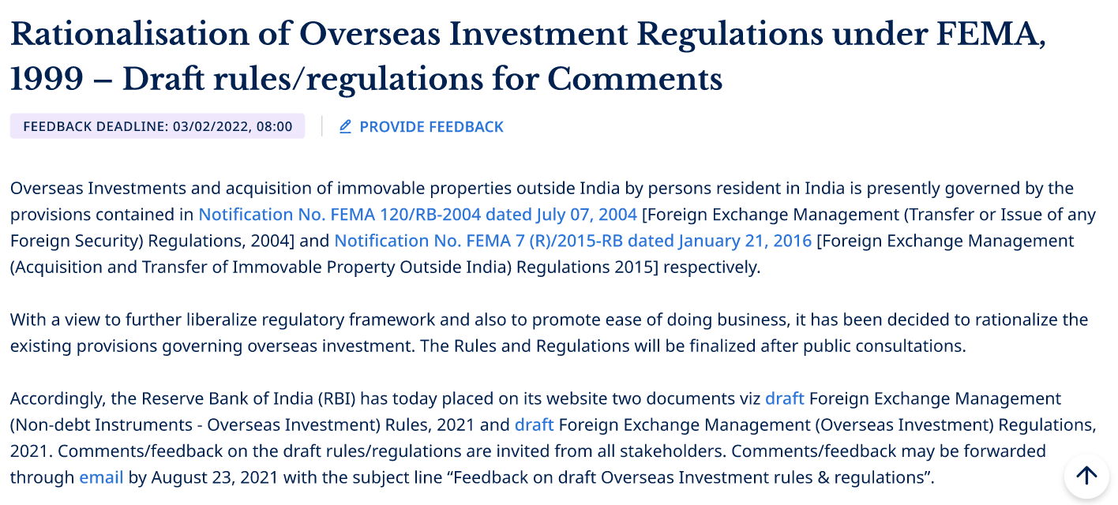
Disclaimer: The ‘provide feedback’ field is optional. We value your privacy and the information provided through the ‘provide feedback’ field.

- About Us > Organisation and Functions > Offices > Outline map of India.
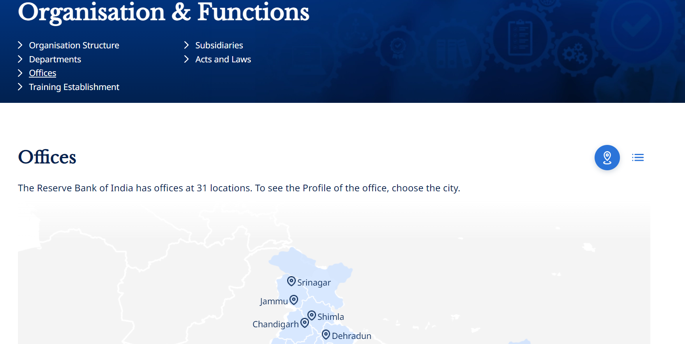
Disclaimer: The maps displayed on the RBI website are for reference only.

